Registered Charity no: 517724

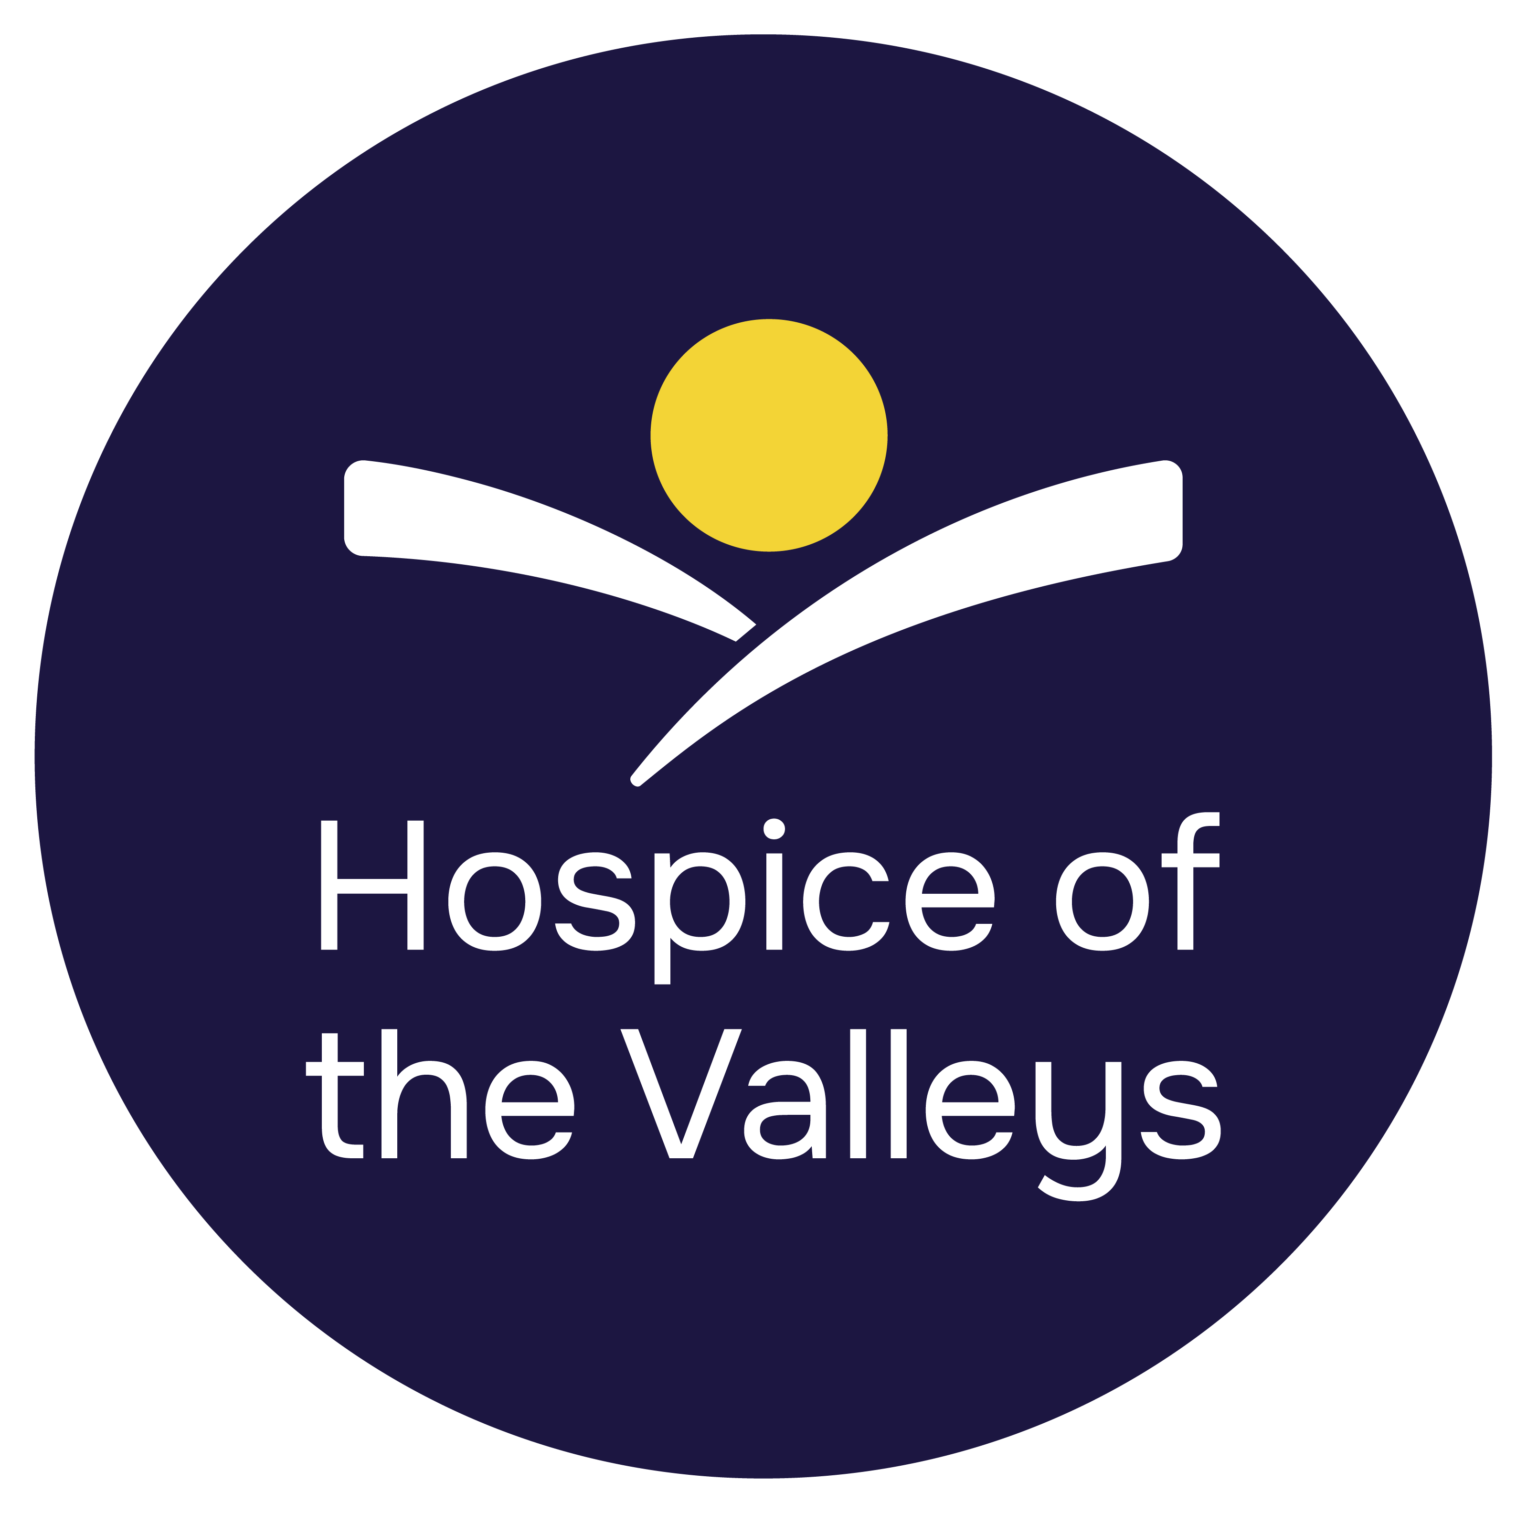
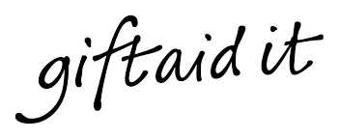

Help us make your donation go further

If you Gift Aid your donation you will boost its value by 25p for every £1 you have given. Therefore for every £1 you give, Hospice of the Valleys will receive £1.25!
By completing this form you are confirming that you are a UK taxpayer and understand that if you pay less Income Tax and/or Capital Gains Tax than the amount of Gift Aid claimed on all the donations in the tax year it is your responsibility to pay any difference.
This declaration also relates to all donations you have made to Hospice of the Valleys in the past four years and all donations until you notify us otherwise.

For completion by donor

Title _____ Initial ____ Surname___________________________________
Home address _____________________________________________________
Town _______________________________________ Postcode______ _____
Email ____________________________________________________________
Signature _______________________________ Date __________________

You can find more information on Gift Aid at
www.gov.uk/donating-to-charity/gift-aid

